PID Closed Loop Control of CNC Spindle
ECEN 4138 Fall 2017
The goal of this project is to design and implement a closed loop PID controller for a CNC machine spindle. In this case the machine is a small benchtop type mill with a 500W brushless DC spindle. The spindle is powered with a 3 phase stepped wave approximation electronic speed controller. This is similar to a DC out runner style motor and ESC used in drones. The controller takes a PWM input at 50Hz and converts it into a variable frequency three phase signal that is fed into the motor to control speed. This is a good combination known for low end torque which is important for a CNC machine. The CNC is rated for 50 – 2500 RPM continuous operation, and the bearings can handle up to 3000RPM. Some overshoot above 2500 RPM is allowable, but not sustainable continuously.
Closed loop speed control is needed because spindle RPM is critical to end mill cutting tools loading during milling operation. For each axis, drive stepper motors are commanded to step at a predetermined rate, and it drives the end mill cutting tool into the metal being machined. If the RPM on the spindle is not at a known constant value it will result in the cutting tool biting off bigger or smaller bits of metal. With open loop control, as the spindle RPM decreases the chunk of metal (called chip size) increases further loading the spindle resulting in further decreasing the spindle RPM until failure.
Initial Controller Goals for this project:
- Overshoot of Mp = 15% or less.
- Rise time of less than Tr = 1s, and settling time of less than Ts = 2s from step input of 1000 RPM.
- Capable of sustained RPM under HSM machining at optimal chip loading.
Machine Encoder and Panel Build:
It was necessary to design an encoder for my machine. Eventually I will implement quadrature, but decided to simplify the tuning process and designed a single input encoder. I used a sealed Hall Effect sensor that would be more durable when exposed to oil and metal chips. 6 magnet nodes are positioned every 60 degrees around the spindle shaft and held in place with a 3D printed ring. Super glue was used to ensure that they would not dislodge at speed, and to prevent shifting of the ring over time. In the future I could add a second Hall Effect sensor positioned 90 degrees from the other sensor and achieve quadrature encoding with ~20 degrees of overlap based on the square wave pulse output that was observed.
Using this encoder, it became necessary to update the control interface to allow for efficient tuning. Input boxes and critical signal indications were added to the machine interface allowed the user to input PID values and apply them in real time. LinuxCNC has a pretty handy built in oscilloscope, but it has very limited memory. It stores about 4 seconds worth of data which was just enough to complete the testing on the machine.
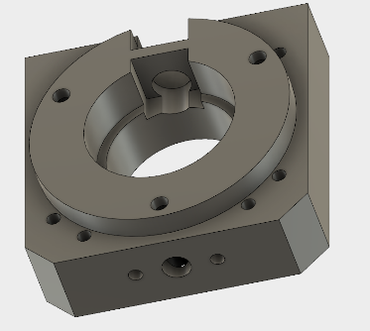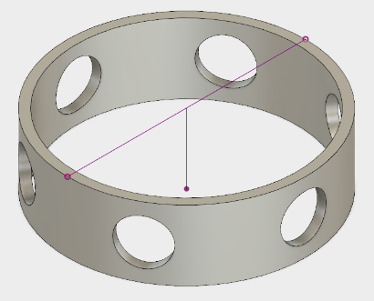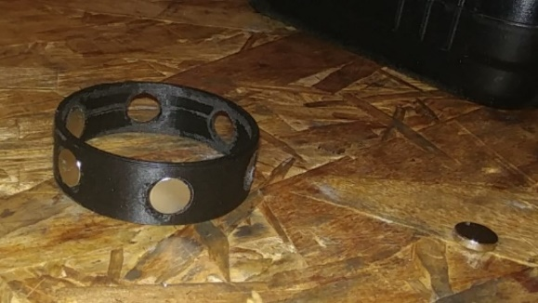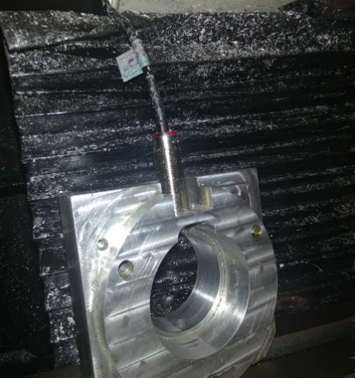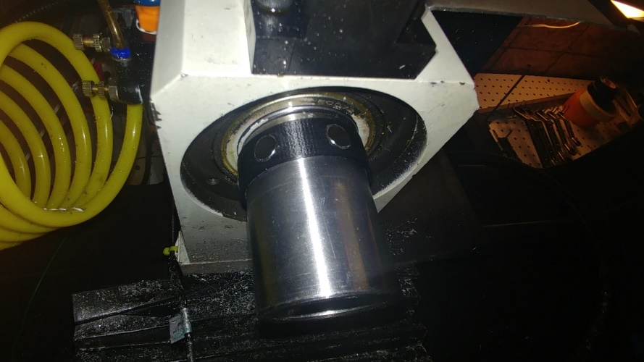
Figure 1) Design and Implementation of Spindle Encoder
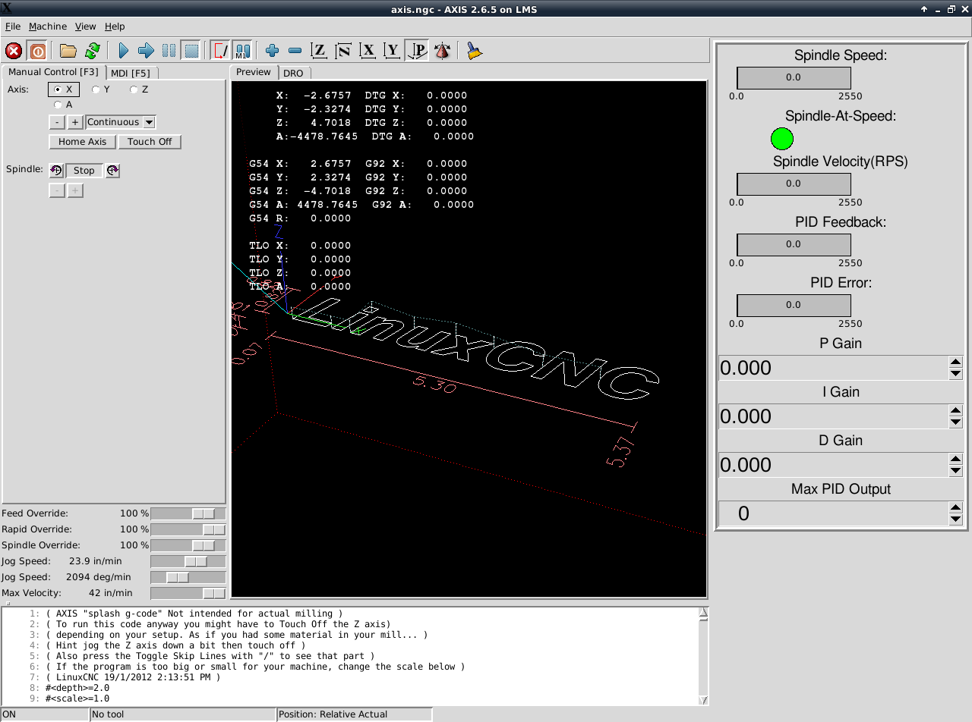
Figure 2) Custom Axis Interface for PID Tuning
In the right side box the user can enter in PID gain values, as well as maximum controller output. PID feedback, error, and spindle velocities as well as filtered spindle speed are output to a bar type outputs. I will describe the filtering characteristics and reasoning later in this report. The Spindle At Speed indicator is a comparator that measures the difference between command and feedback signals. It will be green only when the PID command and feedback values are within 2%.
The panel was built and saved in the custompanel.xml file where input variables that are referenced in the custom_postgui file are defined. The inputs point to the net values in the .hal file to apply them to the machine in real time.
Machine Testing Without PID:
Measurements are taken with PID values set to zero. This gives me a base line for the initial testing values. I measured the feedback (blue), PID controller output (white), and filtered spindle output (green) step response to a command input of 1000 RPM.
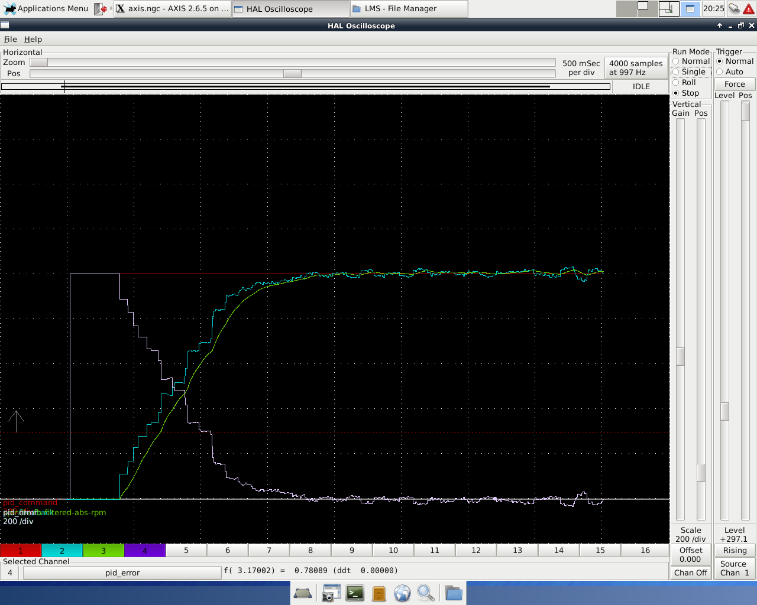
Figure 3) Step Response with no PID input
As you can see in the figure above, the spindle gets to speed but the PID error immediately jumps to a maximum value of 1000. PID values are all set to 0, so there is no contribution to the system response, but having this severe input to the plant will cause issues and instability in the controller during operation. The solution is to run the PID output signal through a low pass filter that will take some of the jagged peaks off of the signal and smooth the values that are passed to the plant input. I found this to be necessary through experimental testing. The controller would respond as anticipated, but would have a “shaky” sound where you could hear the spindle RPM jittering a little bit.
There root cause is a rather slow sampling frequency of the spindle encoder in the motor controller. It results in the jagged step response seen on the blue line above. This was a hardware design issue that cannot be changed in the scope of this project. I filtered the encoder input shown in green, but did not apply it to the PID controller input. This is something that I will do further testing on in the future to optimize the filtering and where it is best applied in the system. There appears to be a delay in the filtered waveform, and I did not want that to affect the response of the system during the initial testing. The raw encoder input is fed into the controller, and only the output is filtered to smooth response. The filtered encoder was only used for the display value in the HMI so that the user could see the spindle RPM without the fluctuations and pulses visible in the raw encoder input.
During initial testing, I could see that there was a massive impulse when the step input was applied. This resulted in a “ringing” sound accompanied by intense acceleration and dangerously high (50 – 60%) overshoots. The ringing may have been motor pole slippage. To combat this, I set a maximum PID controller output of 1000. This is less than 50% of total spindle RPM and seemed like a good basis for testing. The motor had swift, but not too aggressive acceleration, and still achieved a rise time of less than 1 second. This step was taken to protect the equipment, and did result in a uniform linear rise time across all controller types. Without it there were large differences in rise time.
I measured the steady state error across the rpm range. I used increments of 200 rpm and verified the RPM with the controller Spindle Speed value, and with a hand tachometer. I averaged the two spindle rpm values and compared to command input to get the steady state error. This gave me confidence that my spindle speed value was accurate on the HMI panel, and provided a good base line for further comparison.
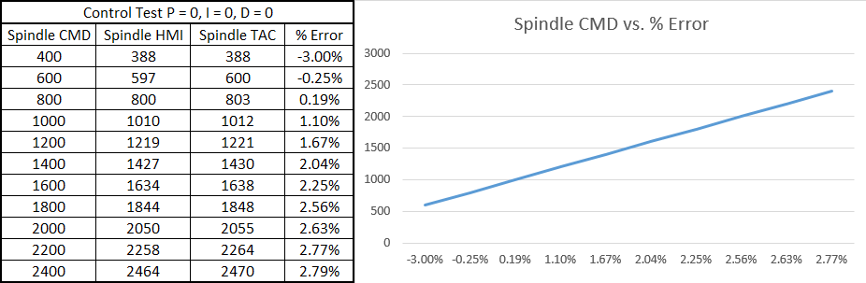
Figure 4) Initial Steady State Error

PID Tuning Using Ziegler – Nichols Method:
I am going to use the Ziegler-Nichols method to tune the controller. This method is designed around disturbance rejection, which will help to satisfy the third goal for this controller. First I set integral and derivative gains to zero, and slowly raise the proportional gain until I can see a stable oscillatory response. This will define my oscillation period Tu.
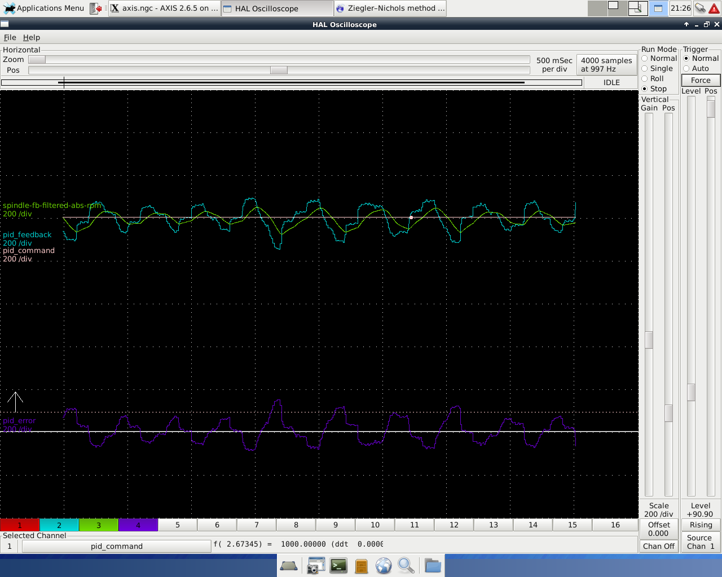
Figure 5) Tu ripple due to Proportional Gain Reaching Instability
I measured the period of the wave and averaged over several trials. Using the waveform above I calculated Tu = 0.646 s. My proportional gain setting was Ku = 4.7 and I will use this value for my ultimate process gain. I will set the controller PID values and observe the P, PI, PD, PID, and Pessen Integral Rule response to a step input per the Ziegler-Nichols method. From this point I will tune the controller to achieve a response that will hopefully meet my design goals.
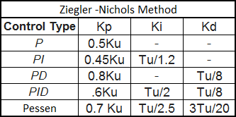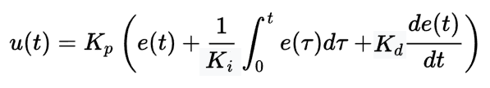
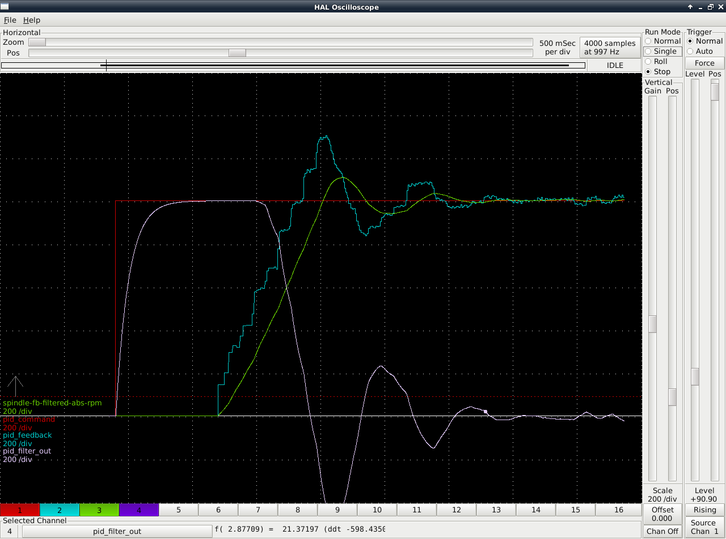
Figure 6) P Controller; P = 2.35, Tr = 0.8, Ts = 2.99, Mp = 30.4%
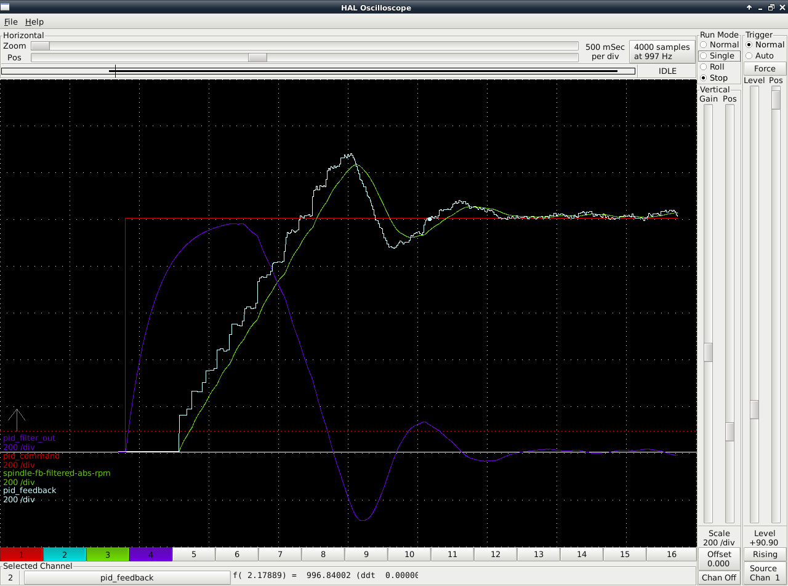
Figure 7) PI Controller; P = 2.115, I = 0.538, Tr = 0.81, Ts = 2.8, Mp = 27.6%
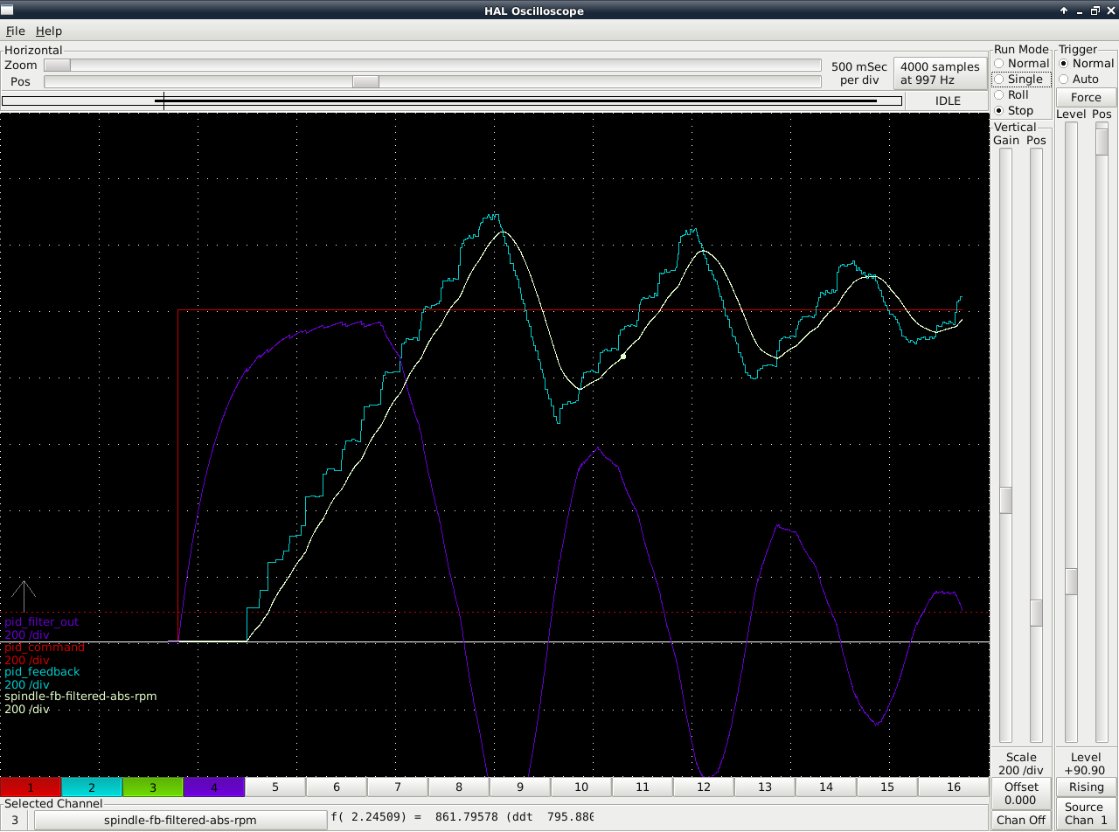
Figure 8) PD Controller; P = 3.76, D = 0.081, Tr = 0.8, Ts = ~6, Mp = 28.8%
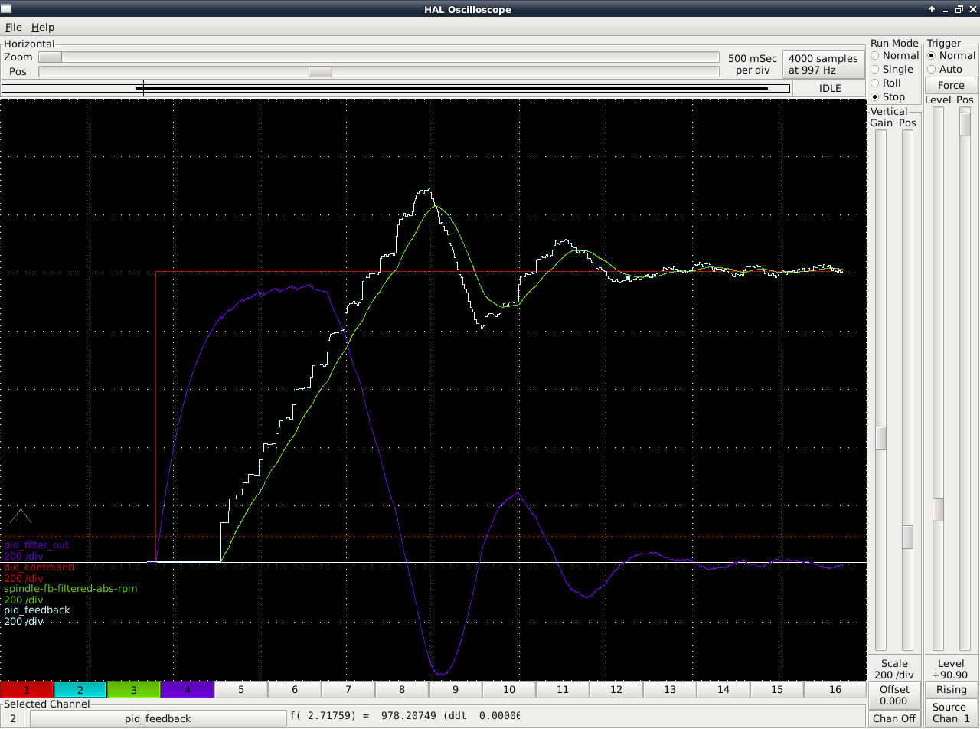
Figure 9) PID controller; P = 2.820, I = 0.323, D = 0.081, Tr = 0.8, Ts = 2.95 Mp = 28.8%
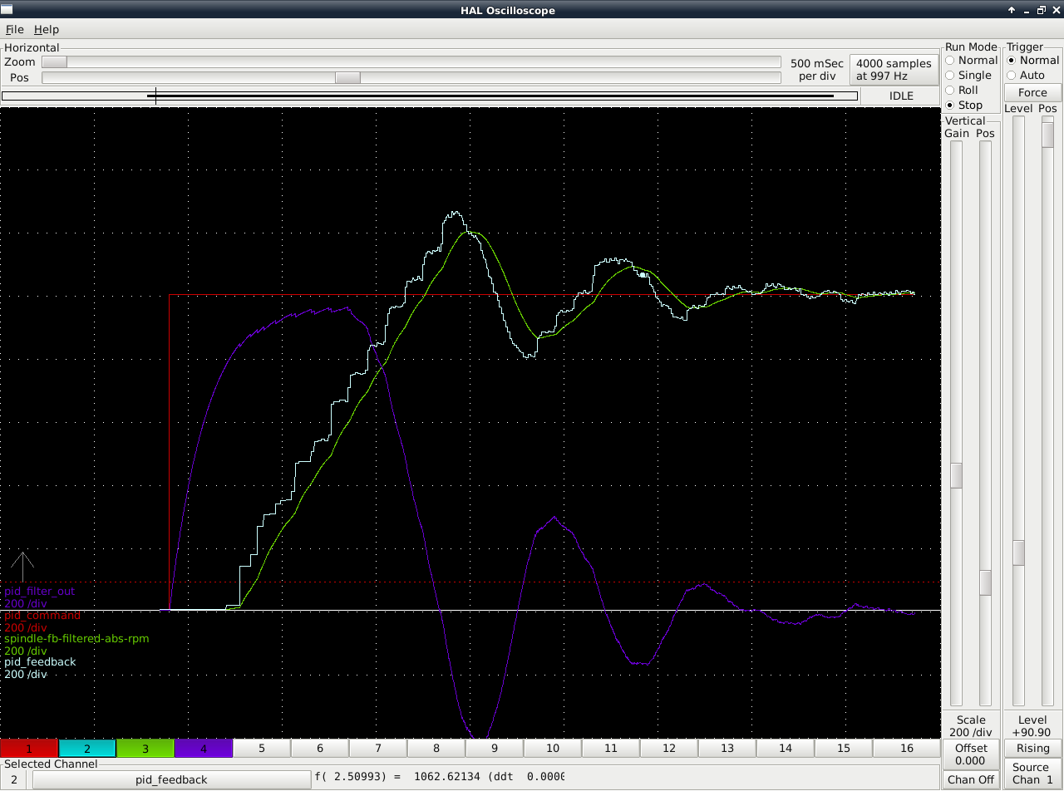
Figure 10) PID Pessen; P = 3.29, I = 0.258, D = 0.097, Tr = 0.8, Ts = 2.22, Mp = 25.7%
Comparing the controllers:
The response delay was 33 – 38 milliseconds for all controllers except Proportional, which had an 80 millisecond delay. This was not expected, and will require further testing to ensure that the values were saved correctly in the controller.
All controllers as configured have too high of an overshoot, and none of them meet the settling time goal that I set out. I decided to lower the maximum output to lower the overshoot, and increase the D gain to try to minimize the oscillatory response out of the controller.
After tuning the PID the values I selected are P = 1.65, I = 0.323, D = 0.2 and Max output = 650. Below are 0 to 1000RPM and 0 to 2200RPM step response using these values. Increasing the proportional gain causes more overshoot, and generally drives the controller output up to maximum faster. Significant changes in the maximum output generally have a minimal effect on rise time, but did help to reduce overshoot. Integral control causes the system to turn faster and head toward the commanded value, but could increase the oscillatory response and thereby increase the settling time. Derivative control is a double edged sword. It can reduce overshoot and get the system tracking toward the command value sooner, but as the error value gets smaller it causes the machine to slowly approach the command value. This resulted in a slower “walk in” to the final value from above the command set point.
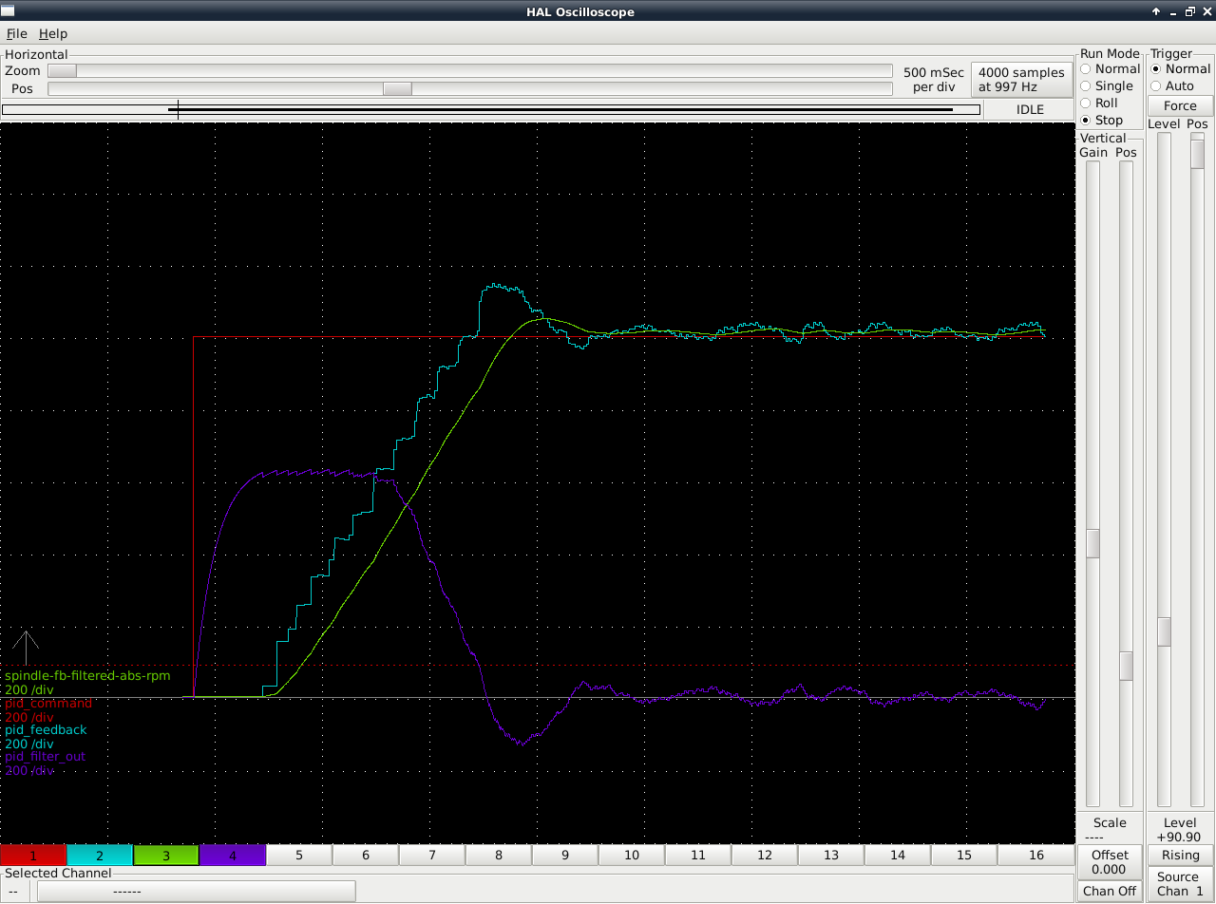
Figure 11) My PID; P = 1.65, I = 0.323, D = 0.2, MO = 650, Tr = 0.845, Ts = 1.829, Mp = 14.7%
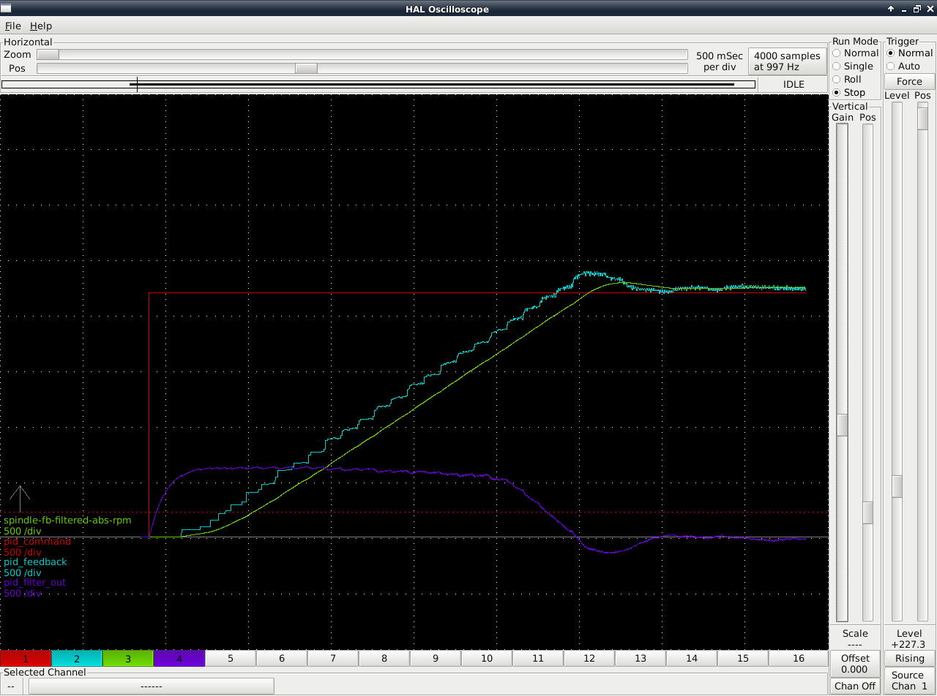
Figure 12) My PID Ramp to 2200 RPM Tr = 1.81, Ts = 3.19, Mp = 8.7%
Tuning this controller has been a fun and challenging experience. My first approach was to build a model of the system using general rotational inertias and motor input characteristics. This proved to be inaccurate, and I was not able to resolve the discrepancies. I believe that the sources of error stem from not being able to disassemble the spindle to measure the weight. This would destroy the bearings because they are pressed on, and ANSYS inertial analysis is beyond the scope of this project. The signal output from the motor controller to the spindle was sinusoidal, but it was not a clean balanced step approximation. It appeared to be between a sine wave and a sine approximation of a saw tooth wave with high frequency noise throughout. This is a cheap machine, and I would assume that many shortcuts were made during the design and fabrication of the driver. As you can see by the initial machine step response the controller does have some damping capability. These factors introduced enough uncertainty to make the model simulations not accurate enough to be useful.
Future testing of different PID tuning methods could result in better performance. The Ziegler-Nichols method was used to overcome the lack of system model design incorporating a second order transfer function to describe the machine operation. This method provided a great starting place to tune the system and to end up with a fantastic controller for my CNC spindle. The information obtained during this process could be used to further refine the system model and potentially result in a better functioning controller.

