Hawe Hydraulic Power Pack

Model:
Hawe FP12M - H 0.73/ K 1.3 W5 A3/140 – VBO
1.4 l/m
180 Bar
380 V 50 Hz
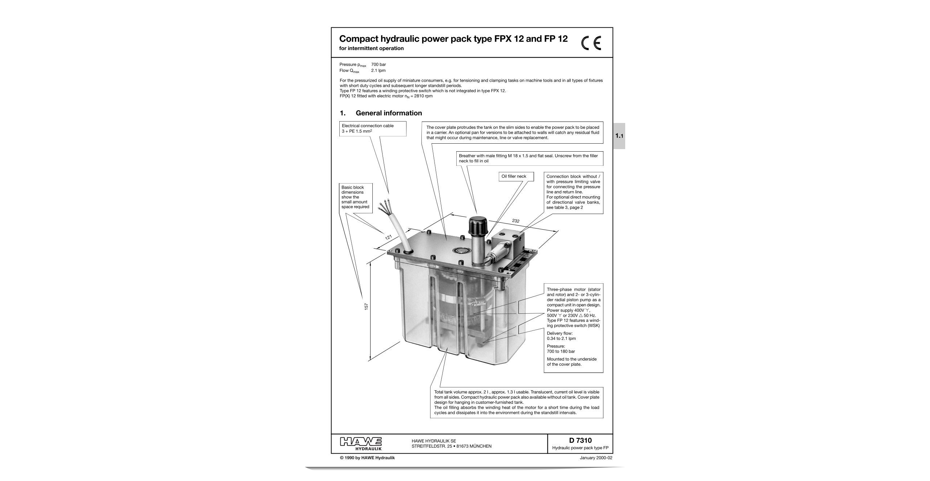
FM – HHH 1 G 24 – X 6W - 2/120

